Emily Chung
EHS Conference 2026 - New Researchers Paper
Word Count: 2,738

Taming Mighty Wildernesses: Housing Reform and Neighbourhood Change in Manchester, 1851-1901

Introduction
Early British industrialization initiated unprecedented demographic growth centred on towns and cities making Britain predominantly urban by 1850. The speed and scale of this growth, however, increased pressures on urban infrastructure and housing stock, creating breeding grounds for disease. By the mid-century, Manchester had become the third largest city in Britain and as a symbol of industrialization, it reflected both its progress and the ills brought with it. The city was a contrast of ‘palaces of merchant princes’ and ‘mighty wildernesses of building, in which the incurable ills of society rankled’, reflecting its diverse population and occupational structure. Pollution, density, and the pressures of urban life, however, produced alarming high rates of mortality and disease.
As in other cities across Britain, the 1840s marked a turning point in the growth and administration of Manchester’s urban fabric with the consolidation of local authority and the introduction of new regulations seeking to tackle both the physical and ‘moral’ conditions of its population. Social and public health reports leading up to this period depicted Manchester as being overrun by disease-ridden slums, and prescribed municipal intervention in order to rebuild a healthier city. The early and unregulated growth of British industrial centres put the poor at the mercy of landlords and developers who maximized their profits by renting units to as many as would take it, resulting in a prevalence of cellar dwellings housing the urban poor under the worst conditions. In parallel, the social fragmentation experienced by its population was coming under increasing scrutiny and condemnation, with segregation blamed for the ‘immorality’ of its labouring classes. In a reprimanding address, Canon Richard Parkinson pointed to ‘ignorance of each other’ as the ‘one great impediment in the way of relieving want and distress’. These Victorian ideas of moral improvement extolled that virtues could be learned through socialisation and dependent on ‘seeing and being seen’. Over the following decades, the continued expansion of the township created opportunities for local authorities to guide urban development according to its new principles, using building legislation and the growing housing stock to tame its ‘mighty wildernesses’.
It has, however, been historically difficult to assess the extent of residential change with any precision; historians and geographers concerned with the issue have largely relying on generalized returns from public health and census reports or qualitative descriptions of urban life. The recent digitization of census data, however, has vastly expanded the potential for observing residential change both spatially, within and across individual towns and cities, and longitudinally, to assess the speed and extent of neighbourhood transitions. Census data provides detailed but spatially limited insight into demographic structures while historical maps and surveys supply information regarding urban footprints and morphological changes; linking the two enriches possibilities for analysis, allowing historical researchers to uncover residential patterns with greater nuance and precision.
This paper offers a replicable, extensible framework for assessing and visualizing the spatial dimension of residential change combining multi-scalar factors pertaining to micro- and macro-conditions. It proposes an exposure index to measure interactions between individuals of different classes which is then used alongside supplemental variables regarding density and diversity in a principal component analysis, to develop a typology for cartographical visualisations of residential change.

Literature Review
Measures of residential segregation have a long history in urban sociology and human geography, from early qualitative approaches emerging from the Chicago School to increasingly formal quantitative indices. In 1955, Duncan and Duncan introduced an index of dissimilarity based on segregation curves which became the standard for quantifying segregation for two decades, at which point Cortese, Falk, and Cohen (1976) exposed the systematic mathematical biases introduced by the Dissimilarity Index, curtailing its popularity and opening the debate on measures of segregation. In following years, new metrics for segregation were introduced including Massey and Denton’s seminal ‘axes’ of segregation, yet most of these studies relied on predetermined areal units such as census tracts, often obscuring or distorting boundary conditions (known as the ‘modifiable areal unit problem’), and relying on binary groups for comparison. Since the early 2000s, however, segregation metrics have continued to improve by addressing these considerations, focusing on more localised spatial environments and across a greater range of groups, though historians have been slow to integrate such methods into their work.
In defining spatial units to reflect socially-relevant relationships, the notion of ‘neighbourhood’ is important to this paper. As social scientists have noted, the multidimensionality of a neighbourhood includes demographic, economic, and infrastructural conditions which make it impossible to define operationally but allow for researchers to employ it using the parameters relevant to their study. The ‘neighbourhood’, furthermore, involves a qualitative dimension which is undermined by enforcing spatial uniformity, and overlaps with an idea of ‘community’ which includes spaces beyond the home. In a city as dense as Manchester in the Victorian era, however, where commuting was almost exclusively pedestrian, the residential neighbourhood remains one of the key contexts for interaction.

Data
While city-wide studies of British Victorian urbanism have typically been restricted in either breadth or depth by the lack of easily manipulable geographic data and the labour-intensiveness of processing individual-level demographic data, the digitization of source material over recent decades has broadened the possibilities for localised neighbourhood studies. The Integrated Census Microdata (I-CeM) project, in particular, has involved the digitisation of the British Censuses of 1851-1921 which include individual-level demographic, occupational and geographic information. Geographic information is provided at several scales: the parish, representing the township of Manchester; the registration sub-district, of which there are three in Manchester; and a residential street address, providing a precise building location. Figure 1 presents the population change across Manchester’s three registration sub-districts. The unevenness of change in Manchester is striking — the population of its Central subdistrict declined by nearly sixty per cent over this period, while St Georges sub-district, to the north, went from being the least populous in 1851 to the most by 1881.

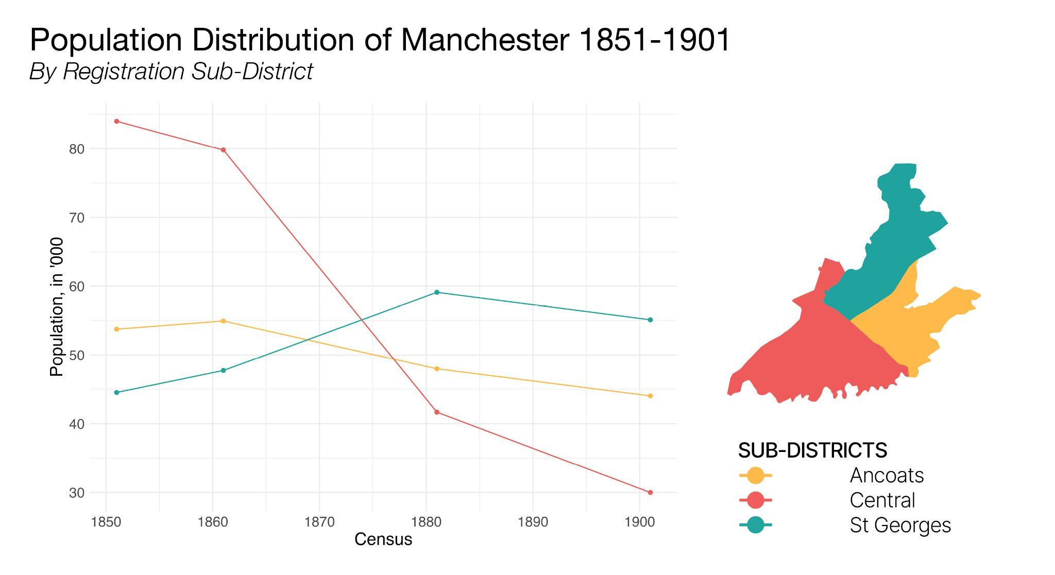
Figure 1. Population Distribution of Manchester 1851-1901, by Registration District.

Geocoding records using residential addresses vastly improves the potential for more precise analysis. This paper relies on a database linking individual records from the I-CeM database to individual buildings across the city. This database includes its own class scheme derived from the 1911 Registrar-General’s for the social classification of occupations and refined using nineteenth-century wage data to better reflect the status-structure of Victorian Manchester. The six classes are defined as follows:
- Professional Occupations, including doctors, engineers, national defense officers and clergymen
- Managerial and Technical Occupations, and Dealers, including shop owners, jewellers, and news agents
- Skilled Occupations, including many employed in the transports, machine and building industries, and clerks
- Partly-Skilled Labourers, including service workers, police and national defensemen, stone miners and quarriers, and labourers in semi-specialist industries (wire, tin, wood)
- Unskilled (General) Labourers
- Unskilled (Textiles, Mining, Agriculture) Labourers

In the following analysis, the term ‘working-class’ refers to individuals from classes three through six, which include the range of skilled and unskilled labourers as well as service workers, moving away from a binary assessment of difference towards a more refined estimation of social and geographic distance. In other words, it asks not only if individuals are different and distant, but how different and distant.
Source material regarding the architectural and economic dimensions of Victorian Manchester such as cartographic surveys and trade directories makes it possible to reconstitute the urban morphology, precisely locating each building address. Addresses can then be used as a common variable for assigning geographic coordinates to census data and together, these sources make it possible to reconstruct Manchester’s occupational distribution to the level of the building. Rather than relying on enumeration units which have tended to be irregular, inconsistent, and too large to determine any specific neighbourhood effects, the granularity of this spatial dataset offers not only flexibility in determination of units but the possibility of multi-scalar analysis comparing both neighbourhood and building conditions. In this way, boundary effects are attenuated by performing individual-level indicators to more accurately reflect condition gradients or identify extremes.
To observe changes in residential patterns, the township of Manchester is broken up into a grid of 150-meter tiles, preserving a sense of granularity and precision while simultaneously prioritising legibility, and the use of a cartographic grid facilitates standardization for comparison as well as a representation of spatial relationships. Henceforth in this paper, an individual’s ‘neighbours’ refers to anyone residing within 150 meters, but ‘neighbourhoods’ refer to individual tiles.

Defining Neighbourhood Typologies
Two aspects of Victorian residential reform are observable using the census microdata: density and segregation. These characteristics are assessed individually, within buildings, and across neighbourhoods. Conditions relating to demographic density are straightforward to calculate in aggregate, and can be assessed at the level of individual buildings using address-level records. Segregation is more complex to calculate and requires a variety of approaches dependent on the scale of analysis.
Rather than determining objective thresholds for assessing segregation, the interest here is to evaluate changes over time. To this end, diversity — used in reference to neighbourhoods, heterogeneity — used in reference to buildings, and exposure —used in reference to individuals, are all discussed relative to changes in overall means and quantiles across all census years. Neighbourhood diversity is measured as the working-class proportion within each tile, while building heterogeneity captures the range of occupational classes present at each address. Cross-class exposures are calculated at the individual level to reduce boundary-effects.
Building on indices developed by Meng et al. (2006) for ordinal group measures, I construct an index of cross-class exposure that incorporates both physical and social proximity. The measure captures interaction potential through a distance-decay function scaled by class difference. For each individual j, the exposure score E is calculated as:
${E_{j} = \frac{1}{n_{j}}}_{}\sum_{i = 1}^{n_{j}}{}\frac{ΔC_{ij}}{{D_{ij}}_{}+1 }$
where n_{j} is the number of neighbours within 150 meters, ΔC_{ij} is the class difference between individual j and neighbour i, and D_{ij}​ is the geographic distance between them in meters. To avoid a zero-denominator in cases of co-residence, one meter is added to all denominator values. Alternative distance thresholds produced comparable relative distributions; a 150-metre radius was therefore adopted to align with the neighbourhood tiling. Figure 2 presents the results of these calculations averaged over neighbourhoods.
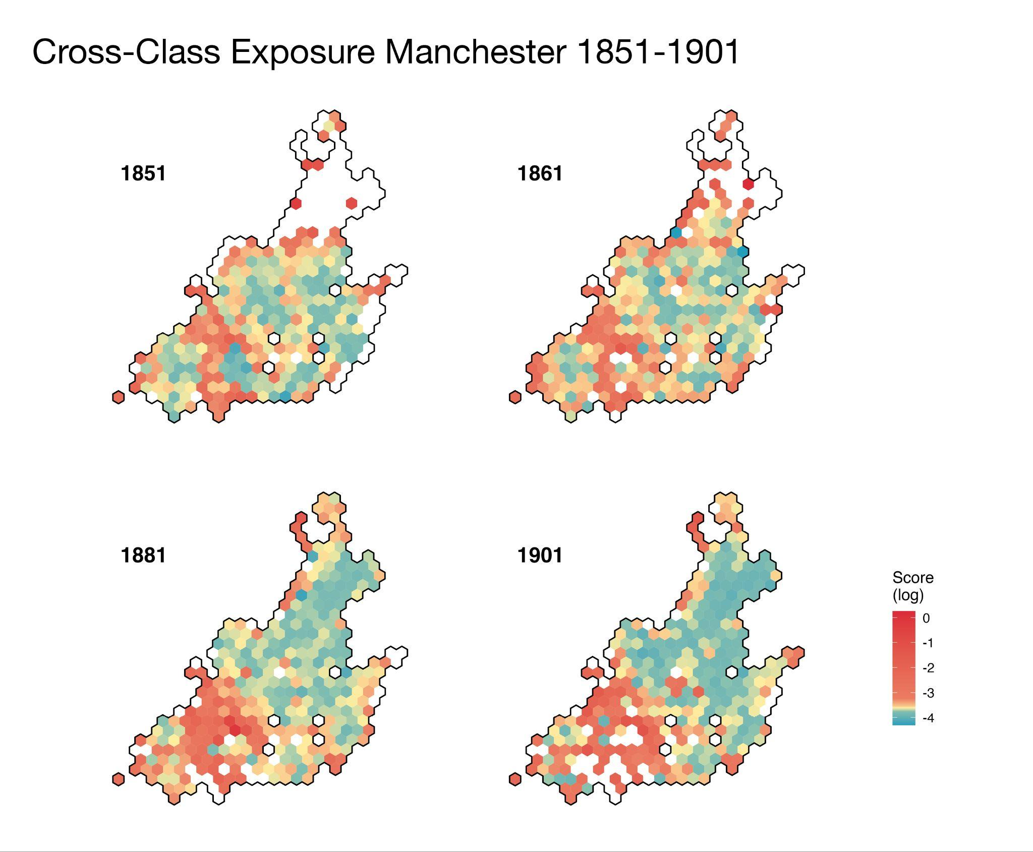
Figure 2. Cross-Class Exposures, Manchester 1851-1901

While essential for overcoming the modifiable areal unit problem, however, these scores obscure the particulars of exposure, as similar exposure values may reflect different underlying residential configurations. For this reason, specific variables identifying neighbourhood diversity and building heterogeneity remain essential in defining residential patterns, with this exposure index offering a complement for reducing boundary effects.
Neighbourhood characteristics are therefore determined along five variables: diversity, i.e. the working-class proportion of the population; heterogeneity, as the average range of classes found in buildings across the neighbourhood; exposure, as the average exposure scores of individuals living within the neighbourhood; neighbourhood density, as the average number of neighbours of individuals living within the neighbourhood; and building density, as the average number of inhabitants per building within the neighbourhood. Constructing a neighbourhood typology involves performing principal component analysis (PCA) followed by hierarchical clustering. PCA was used to reduce these five variables into a smaller number of components capturing the dominant patterns of variation. Most of the dataset variance can be explained from the first three components of the PCA, which cumulatively represent eighty-three per cent of the variance, and these are used for clustering (Table 1).

 | PC1 | PC2 | PC3 | PC4 | PC5
Standard Deviation | 1.37 | 1.18 | 0.93 | 0.68 | 0.62
Cumulative Proportion of Variance | 0.27 | 0.66 | 0.83 | 0.93 | 1.00
Loadings
Exposure Index | -0.48 | -0.41 | -0.37 | -0.68 | -0.01
Building Heterogeneity | -0.56 | 0.38 | 0.05 | 0.12 | 0.73
Neighbourhood Diversity | 0.35 | 0.23 | -0.88 | 0.1 | 0.19
Building Density | -0.55 | 0.36 | -0.24 | 0.31 | -0.65
Neighbourhood Density | 0.18 | 0.72 | 0.16 | -0.64 | -0.13
Table 1. Composition of Principal Components

Each neighbourhood receives a PC-score based on how their characteristics align with the main patterns captured by the principal components. Using the three component scores as coordinates within a three-dimensional PC-space, ‘distances’ between points are calculated for clustering based on similarity. Neighbourhood typologies, or ‘clusters’, are therefore defined by the summary characteristics for each group. Figure 4 illustrates the characteristics of each type, and Figure 5 shows how they are distributed spatially over the period of study.
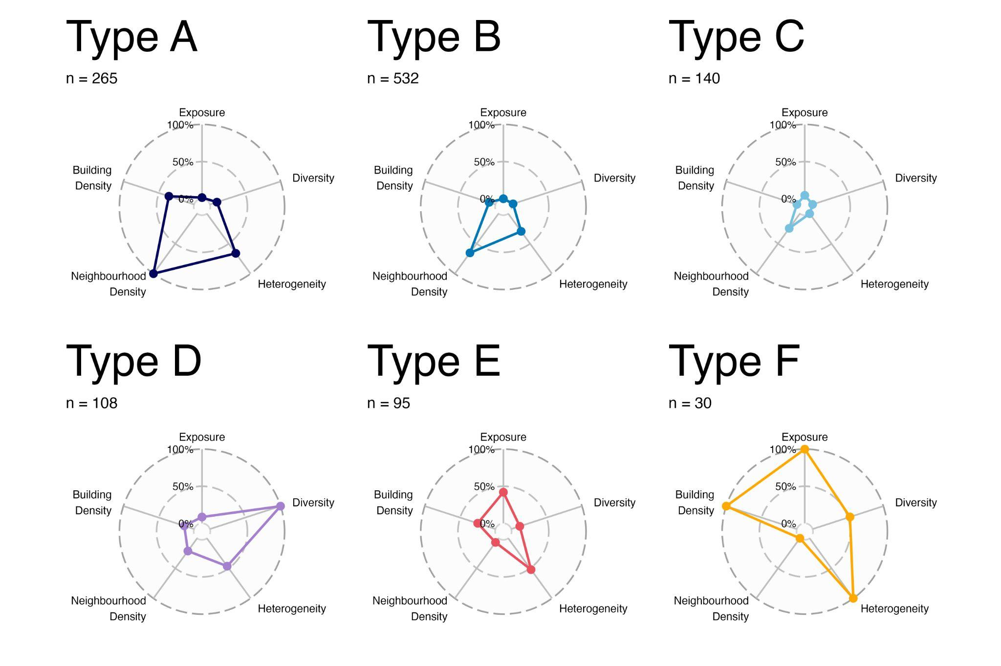
Figure 4. Summary Characteristics of Neighbourhood Typology.

Neighbourhood types are defined as falling into two categories: predominantly residential or mixed use. Types A, B and C belong to the former, with generally higher neighbourhood densities and similar variable relationships, but with respective declines in population and building densities as well as their building heterogeneities. Types D, E and F are mixed-used and characterised by much lower neighbourhood densities, suggesting greater space-use for commercial and manufacturing operations and confirmed by cross-referencing against the Ordnance Survey of 1889-90. Type D neighbourhoods are categorised as mixed residential and commercial, with particularly high rates of neighbourhood diversity. These were mostly centrally located and composed of mix-used buildings combining shops and housing. Type E were low density neighbourhoods with a mix of housing and manufacturing, while Type F were very low density predominantly-commercial and manufacturing neighbourhoods with most individuals listed as residing in very high-density inns and pubs.
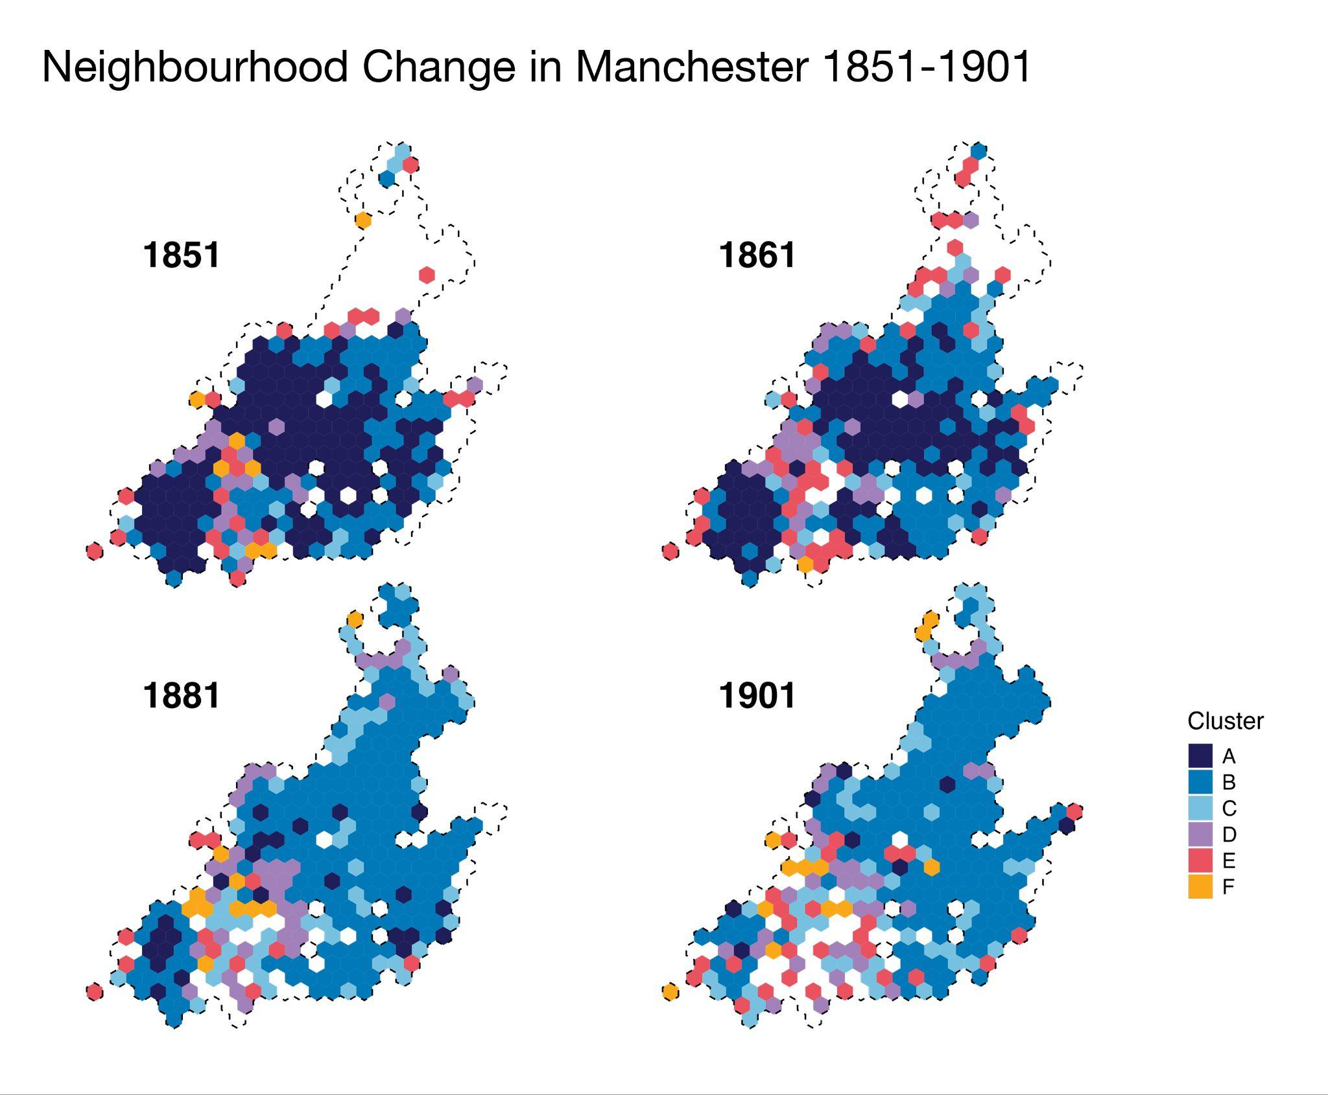
Figure 5. Neighbourhood Change in Manchester, 1851-1901

While neighbourhoods of each type were found across the period 1851-1901, neighbourhood change and urban residential reform are clearly demonstrated in the shift from the dominance of Type A to B. This shift reflects the impact of mid-century slum clearance, which replaced overcrowded housing with commercial uses and displaced lower-density residential development from the city-centre toward the urban periphery.

The Type A to Type B transition is best characterised by the Oldham Road Dwelling Scheme, completed in 1893. Located at the boundary of Ancoats and St Georges, on the side of the former, this neighbourhood epitomises the municipal effort to tame the ‘mighty wildernesses of building’ which had arisen by the mid-century.
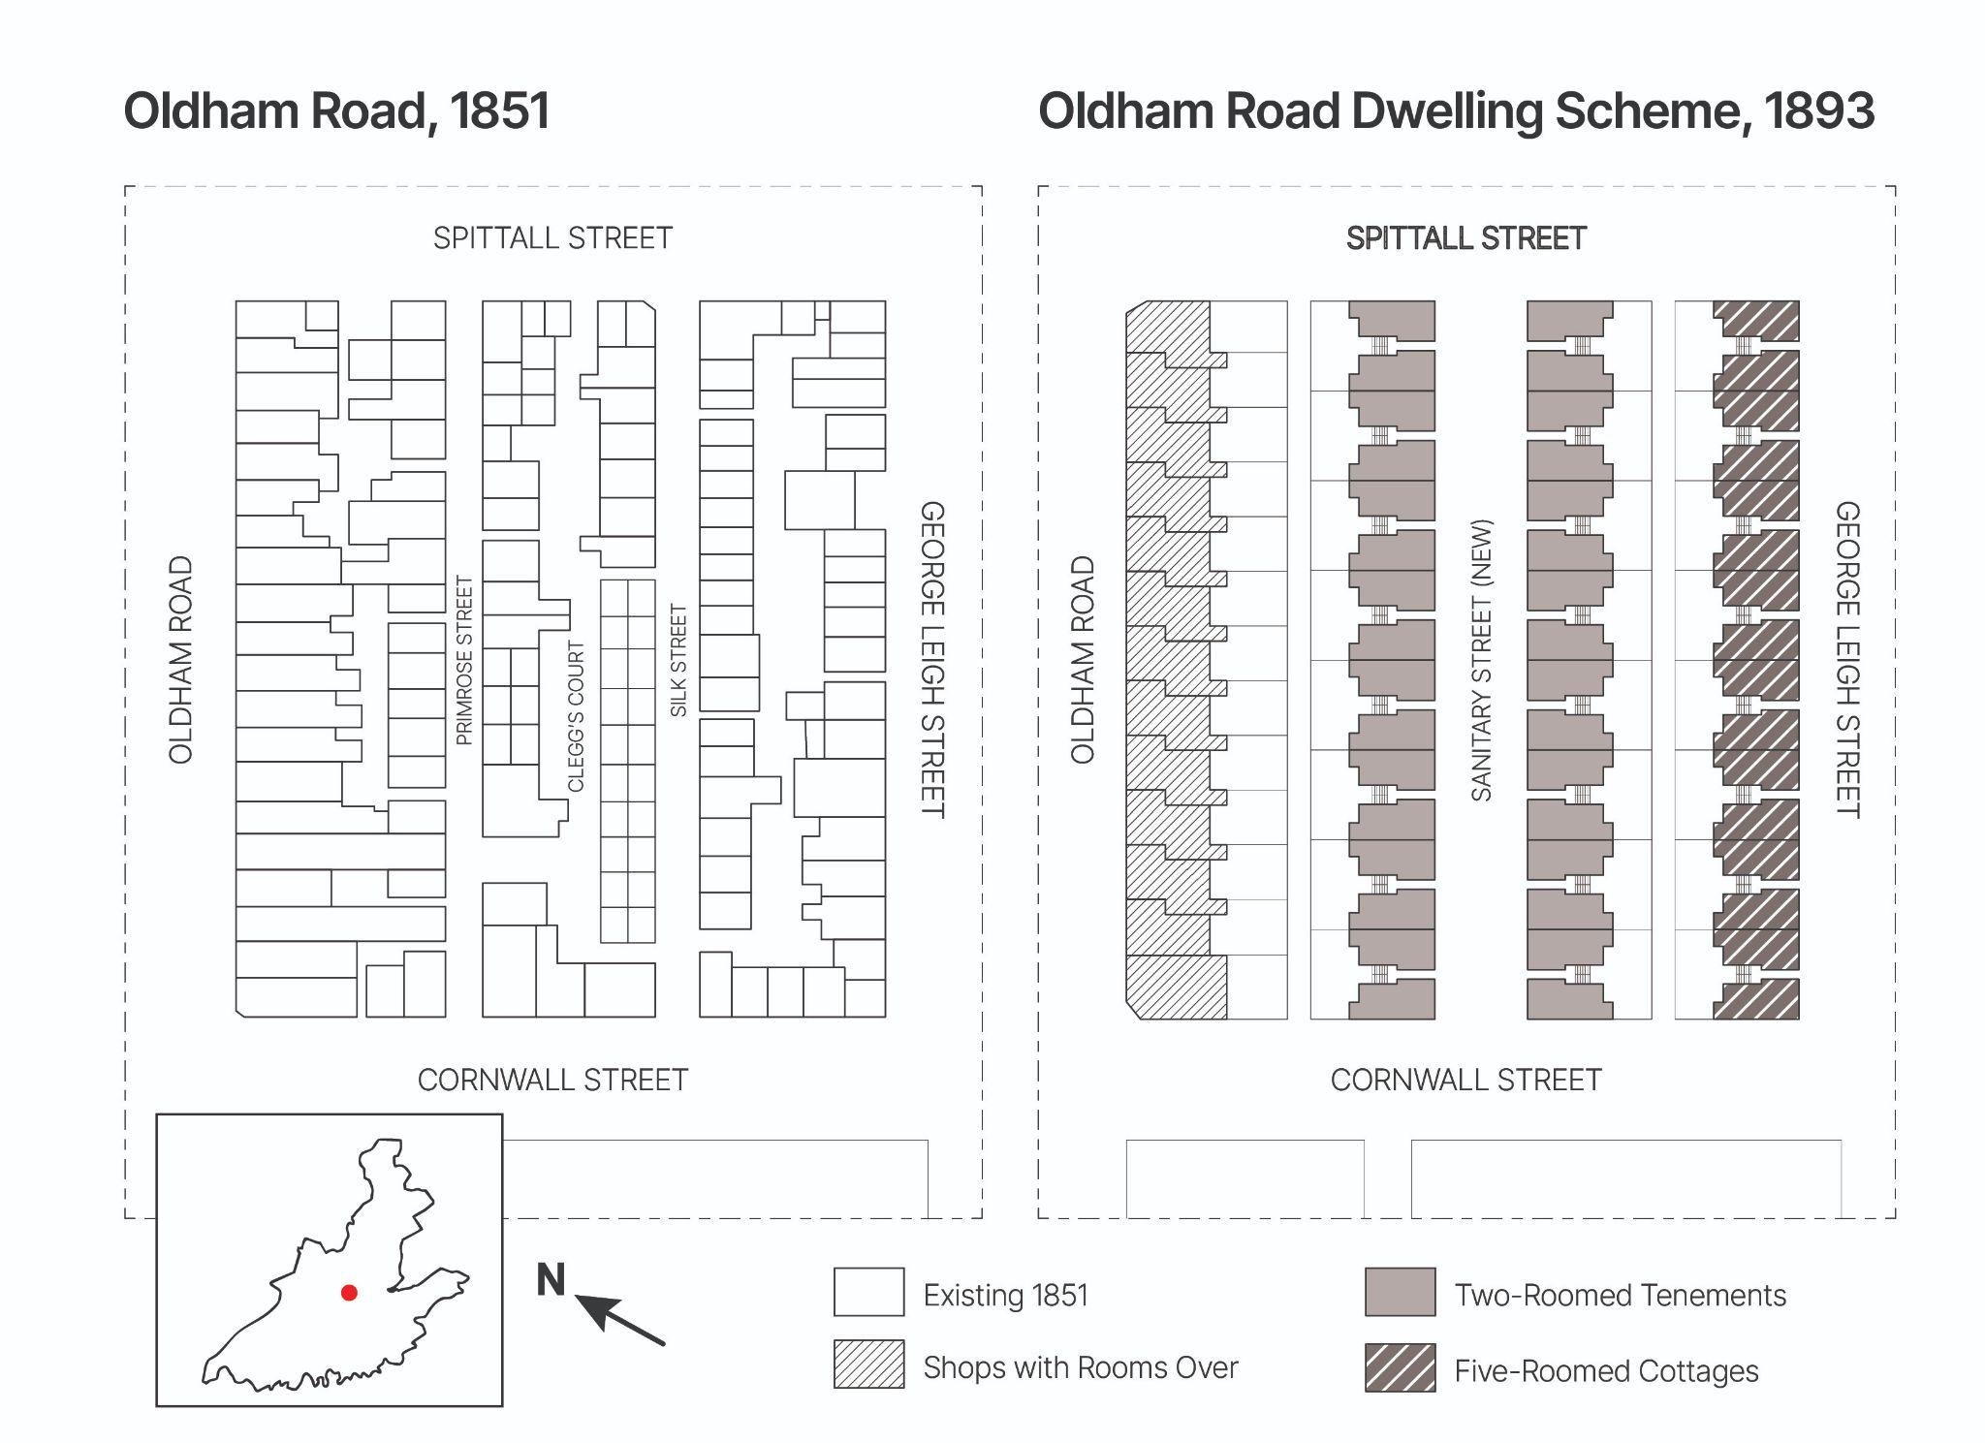
Figure 8. Oldham Road Case Study, Bird’s Eye View; Adapted and Reproduced from Ordnance Survey 1851 and documents from the National Archives (HLG 24.59).

 | Class 1 |  | Class 2 |  | Class 3 |  | Class 4 |  | Class 5 |  | Class 6 |  | Total
 | Pop. | % | Pop. | % | Pop. | % | Pop. | % | Pop. | % | Pop. | % | Pop.
1851 | 18 | 2.49 | 102 | 14.1 | 207 | 28.6 | 85 | 11.8 | 69 | 9.5 | 193 | 26.7 | 1050
1861 | 20 | 2.88 | 79 | 11.4 | 198 | 28.5 | 79 | 11.4 | 107 | 15.4 | 194 | 28.0 | 991
1881 | 6 | 1.1 | 117 | 22.0 | 127 | 23.8 | 73 | 13.7 | 109 | 20.5 | 96 | 18.0 | 783
1901 | 5 | 1.8 | 46 | 16.1 | 73 | 25.5 | 41 | 14.3 | 76 | 26.6 | 39 | 13.6 | 410

Table 2. Oldham Road Case Study, Occupational Composition 1851-1901.

In 1851, the area housed over one thousand individuals, with nearly a third of unskilled textile workers. Housing was dense and cramped with terrace housing leading onto narrow streets and back courts. By 1881, the population had declined slightly, likely as a result of cellar closings, though a glance at the Ordnance Survey of 1889-90 reveals that the area’s architecture had mostly remained intact. In the final years of the century, however, a reconstruction scheme was implemented which drastically changed the character of the neighbourhood. Small, densely populated buildings were completely leveled and the area reorganized into an orderly, far lower density scheme. Where two minor streets and a back court had sat between Oldham Road and George Leigh Street, the scheme instated one central street between these two symbolically named ‘Sanitary Street’. The buildings along Oldham Road remained mixed-use, with shops on the ground floor and rooms above them, while the three sets of sixteen residential buildings lining Sanitary and George Leigh Streets were composed of two-room cottages or five-room tenements. With these changes, the population was nearly halved. While the area maintained a diverse cross section of the population, the frequency of interactions between individuals of different households was substantially lessened as a result of the lowered density of both the neighbourhood and its buildings and reflects the guiding architectural principles of this period, tackling the orderliness and overcrowding of residential neighbourhoods.

Conclusion
Observing and measuring urban change in Victorian cities has been a challenge for historians and historical geographers concerned with the period, due to data availability. As the existing literature has demonstrated through studies of socio-spatial segregation, conclusions are often dependent on the scale of available data. Manchester, one of the earliest industrial cities to develop in Britain, has been a key example of this difficulty as the subject of opposing views regarding the nature and extent of class segregation. Using a recently developed dataset composed of precisely geolocated census data from 1851-1901, this paper proposes a method assessing changes in class segregation and rates of overcrowding at both neighbourhood and building-levels. It presents an index for measuring cross-class exposure independently of traditional areal-units, which is then used alongside indicators of density and neighbourhood diversity to define a neighbourhood typology. This typology facilitates the visualisation of neighbourhood change from 1851-1901, showing how residential developments redistributed the population throughout the city as well as redefining patterns of living through changes in building occupancy. Slum clearances across the centre razed the oldest and densest neighbourhoods of the city, making room for warehouses and railways, while new developments to the north introduced newer, lower-occupancy residential districts. This replicable approach offers opportunities to compare urban developments both longitudinally, as demonstrated in this study, but also cross-sectionally, to compare different cities using similar datasets.

Works Cited

Adshead, Joseph. Distress in Manchester: Evidence of the State of the Labouring Classes In 1840-1842. Henry Hooper, 1842.
Chung, Emily. ‘Proximity and Segregation in Industrial Manchester’. The Historical Journal, October 2025, 1–22. https://doi.org/10.1017/S0018246X25101246.
Chung, Emily. ‘Visualizing Victorian Manchester’. Social Science History, ahead of print, Forthcoming 2026. https://doi.org/10.1017/ssh.2025.10116.
Cortese, Charles F., R. Frank Falk, and Jack K. Cohen. ‘Further Considerations on the Methodological Analysis of Segregation Indices’. American Sociological Review 41, no. 4 (1976): 630–37. https://doi.org/10.2307/2094840.
Davenport, Romola J. ‘Urbanization and Mortality in Britain, c. 1800–50’. The Economic History Review 73, no. 2 (2020): 455–85. https://doi.org/10.1111/ehr.12964.
Demšar, Urška, Paul Harris, Chris Brunsdon, A. Stewart Fotheringham, and Sean McLoone. ‘Principal Component Analysis on Spatial Data: An Overview’. Annals of the Association of American Geographers 103, no. 1 (2013): 106–28. https://doi.org/10.1080/00045608.2012.689236.
Duncan, Otis Dudley, and Beverly Duncan. ‘A Methodological Analysis of Segregation Indexes’. American Sociological Review 20, no. 2 (1955): 210–17. https://doi.org/10.2307/2088328.
Goad, Charles E. ‘Goad Fire Insurance Maps of Manchester’. The British Library, 1887.
Gould, P. R. ‘On the Geographical Interpretation of Eigenvalues’. Transactions of the Institute of British Geographers, no. 42 (1967): 53–86. https://doi.org/10.2307/621372.
Grigsby, William G. Urban Housing Policy. First edition. Taylor and Francis, 2017.
Higgs, Edward, Kevin Schurer, and FINDMYPAST LIMITED. ‘Integrated Census Microdata (I-CeM), 1851-1911’. UK Data Service, 2024. https://doi.org/10.5255/UKDA-SN-7481-3.
James, David R., and Karl E. Taeuber. ‘Measures of Segregation’. Sociological Methodology 15 (1985): 1–32. https://doi.org/10.2307/270845.
Jenks, Mike, and Nicola Dempsey. ‘Defining the Neighbourhood: Challenges for Empirical Research’. The Town Planning Review 78, no. 2 (2007): 153–77.
Kay-Shuttleworth, James. Moral and Physical Condition of the Working Classes Employed in the Cotton Manufacture of Manchester. Frank Cass & Co ltd., 1970.
Love, Benjamin. The Hand-Book of Manchester; Containing Statistical and General Information on the Trade, Social Condition, and Institutions of the Metropolis of Manufactures. Love & Barton, 1842.
Manchester Times (Manchester). ‘On The Social Condition of the Working Classes in Manchester and the Surrounding Areas, January 10th 1852’. 10 January 1852.
Massey, Douglas S., and Nancy A. Denton. ‘The Dimensions of Residential Segregation’. Social Forces 67, no. 2 (1988): 281–315.
Meng, Gang, G. Brent Hall, and Steven Roberts. ‘Multi-Group Segregation Indices for Measuring Ordinal Classes’. Computers, Environment and Urban Systems 30, no. 3 (2006): 275–99.
‘Ordnance Survey, 25 Inch Plans of England and Wales.’ 1915. National Library of Scotland.
‘Ordnance Survey Town Plans: 1:500, Manchester and Salford.’ 1890. National Library of Scotland.
‘Ordnance Survey Town Plans: Ten Feet to One Statute Mile, Manchester and Salford.’ 1849. National Library of Scotland.
Parkinson, Richard. ‘On the Present Condition of the Labouring Poor in Manchester; with Hints for Improving It’. Simms & Dinham, 1841.
Poovey, Mary. Making a Social Body: British Cultural Formation, 1830-1864. University of Chicago Press, 1995.
Reardon, Sean F., and David O’Sullivan. ‘Measures of Spatial Segregation’. Sociological Methodology 34, no. 1 (2004): 121–62. https://doi.org/10.1111/j.0081-1750.2004.00150.x.
Slater, Isaac. ‘Slater’s General and Classified Directory and Street Register of Manchester and Salford and Their Vicinities’. Isaac Slater, Fountain Street and Portland Street, 1850.
Slater, Isaac. ‘Slater’s Royal National Commercial Directory of Manchester and Salford With Their Vicinities’. Isaac Slater, 1883. University of Leicester.
Song, Yan, and Gerrit-Jan Knaap. ‘Quantitative Classification of Neighbourhoods: The Neighbourhoods of New Single-Family Homes in the Portland Metropolitan Area’. Journal of Urban Design 12, no. 1 (2007): 1–24. https://doi.org/10.1080/13574800601072640.
Szreter, Simon. Health and Wealth: Studies in History and Policy. University of Rochester Press, 2005.
Szreter, Simon, and Graham Mooney. ‘Urbanization, Mortality, and the Standard of Living Debate: New Estimates of the Expectation of Life at Birth in Nineteenth-Century British Cities’. The Economic History Review 51, no. 1 (1998): 84–112. https://doi.org/10.1111/1468-0289.00084.
Wohl, Anthony S. Endangered Lives: Public Health in Victorian Britain. Harvard U.P., 1983.
Wong, David W. S. ‘Spatial Decomposition of Segregation Indices: A Framework Toward Measuring Segregation at Multiple Levels’. Geographical Analysis 35, no. 3 (2003): 179–94. https://doi.org/10.1111/j.1538-4632.2003.tb01109.x.
Yao, Jing, David W.S. Wong, Nick Bailey, and Jonathan Minton. ‘Spatial Segregation Measures: A Methodological Review’. Tijdschrift Voor Economische En Sociale Geografie 110, no. 3 (2019): 235–50. https://doi.org/10.1111/tesg.12305.

Benjamin Love, The Hand-Book of Manchester; Containing Statistical and General Information on the Trade, Social Condition, and Institutions of the Metropolis of Manufactures (Love & Barton, 1842), 14; Simon Szreter, Health and Wealth: Studies in History and Policy (University of Rochester Press, 2005), ch. 6.
‘On The Social Condition of the Working Classes in Manchester and the Surrounding Areas, January 10th 1852’, Manchester Times (Manchester), 10 January 1852, 10; James Kay-Shuttleworth, Moral and Physical Condition of the Working Classes Employed in the Cotton Manufacture of Manchester (Frank Cass & Co ltd., 1970), 11.
Anthony S. Wohl, Endangered Lives: Public Health in Victorian Britain (Harvard U.P., 1983); Simon Szreter and Graham Mooney, ‘Urbanization, Mortality, and the Standard of Living Debate: New Estimates of the Expectation of Life at Birth in Nineteenth-Century British Cities’, The Economic History Review 51, no. 1 (1998): 84–112, https://doi.org/10.1111/1468-0289.00084; Romola J. Davenport, ‘Urbanization and Mortality in Britain, c. 1800–50’, The Economic History Review 73, no. 2 (2020): 455–85, https://doi.org/10.1111/ehr.12964.
Joseph Adshead, Distress in Manchester: Evidence of the State of the Labouring Classes In 1840-1842 (Henry Hooper, 1842); Kay-Shuttleworth, Moral and Physical Condition; Manchester Times, ‘On The Social Condition, January 10 1852’.
Richard Parkinson, ‘On the Present Condition of the Labouring Poor in Manchester; with Hints for Improving It’, Simms & Dinham, 1841, 7.
Mary Poovey, Making a Social Body: British Cultural Formation, 1830-1864 (University of Chicago Press, 1995), 33.
William G. Grigsby, Urban Housing Policy, First edition. (Taylor and Francis, 2017), ch. 5.
Edward Higgs et al., ‘Integrated Census Microdata (I-CeM), 1851-1911’, UK Data Service, 2024, https://doi.org/10.5255/UKDA-SN-7481-3.
‘Ordnance Survey Town Plans: Ten Feet to One Statute Mile, Manchester and Salford.’, 1849, National Library of Scotland; ‘Ordnance Survey Town Plans: 1:500, Manchester and Salford.’, 1890, National Library of Scotland; ‘Ordnance Survey, 25 Inch Plans of England and Wales.’, 1915, National Library of Scotland; Charles E. Goad, ‘Goad Fire Insurance Maps of Manchester’, The British Library, 1887; Isaac Slater, ‘Slater’s General and Classified Directory and Street Register of Manchester and Salford and Their Vicinities’, Isaac Slater, Fountain Street and Portland Street, 1850; Isaac Slater, ‘Slater’s Royal National Commercial Directory of Manchester and Salford With Their Vicinities’, Isaac Slater, 1883, University of Leicester.
PCA is an accepted method in the geographical sciences; for examples, see: P. R. Gould, ‘On the Geographical Interpretation of Eigenvalues’, Transactions of the Institute of British Geographers, no. 42 (1967): 53–86, https://doi.org/10.2307/621372; Urška Demšar et al., ‘Principal Component Analysis on Spatial Data: An Overview’, Annals of the Association of American Geographers 103, no. 1 (2013): 106–28, https://doi.org/10.1080/00045608.2012.689236; Yan Song and Gerrit-Jan Knaap, ‘Quantitative Classification of Neighbourhoods: The Neighbourhoods of New Single-Family Homes in the Portland Metropolitan Area’, Journal of Urban Design 12, no. 1 (2007): 1–24, https://doi.org/10.1080/13574800601072640.
Emily Chung, ‘Visualizing Victorian Manchester’, Social Science History, ahead of print, Forthcoming 2026, https://doi.org/10.1017/ssh.2025.10116.
Otis Dudley Duncan and Beverly Duncan, ‘A Methodological Analysis of Segregation Indexes’, American Sociological Review 20, no. 2 (1955): 210–17, https://doi.org/10.2307/2088328; Charles F. Cortese et al., ‘Further Considerations on the Methodological Analysis of Segregation Indices’, American Sociological Review 41, no. 4 (1976): 630–37, https://doi.org/10.2307/2094840.
David R. James and Karl E. Taeuber, ‘Measures of Segregation’, Sociological Methodology 15 (1985): 1–32, https://doi.org/10.2307/270845; Douglas S. Massey and Nancy A. Denton, ‘The Dimensions of Residential Segregation’, Social Forces 67, no. 2 (1988): 281–315.
David W. S. Wong, ‘Spatial Decomposition of Segregation Indices: A Framework Toward Measuring Segregation at Multiple Levels’, Geographical Analysis 35, no. 3 (2003): 179–94, https://doi.org/10.1111/j.1538-4632.2003.tb01109.x; Sean F. Reardon and David O’Sullivan, ‘Measures of Spatial Segregation’, Sociological Methodology 34, no. 1 (2004): 121–62, https://doi.org/10.1111/j.0081-1750.2004.00150.x; For a more complete methodological review, see: Jing Yao et al., ‘Spatial Segregation Measures: A Methodological Review’, Tijdschrift Voor Economische En Sociale Geografie 110, no. 3 (2019): 235–50, https://doi.org/10.1111/tesg.12305.
Mike Jenks and Nicola Dempsey, ‘Defining the Neighbourhood: Challenges for Empirical Research’, The Town Planning Review 78, no. 2 (2007): 157–59.
Higgs et al., ‘I-CeM’; ‘Ordnance Survey Town Plans: 1:500, Manchester and Salford.’
Kay-Shuttleworth, Moral and Physical Condition, 11.
Gang Meng et al., ‘Multi-Group Segregation Indices for Measuring Ordinal Classes’, Computers, Environment and Urban Systems 30, no. 3 (2006): 275–99.
For further particulars on the geocoding process, see: Emily Chung, ‘Visualizing Victorian Manchester’, Social Science History (Forthcoming 2026).
Emily Chung, ‘Proximity and Segregation in Industrial Manchester’, The Historical Journal, October 2025, 1–22, https://doi.org/10.1017/S0018246X25101246.

