Fighting for Free Enterprise: Business, the Institute of Directors and the Rise of Neoliberalism in Britain, 1945-1979.

-

A Paper Submitted to the Economic History Society’s New Researcher Session for the 2025 Conference at the University of Strathclyde, Glasgow

Word Count: 2,681

-

Joseph Moore

The University of Manchester

Email: [Joseph.moore-2@postgrad.manchester.ac.uk](mailto:Joseph.moore-2@postgrad.manchester.ac.uk)

Twitter: Joedcrmoore



1. **Introduction**
   1. **– Historiography**

For economic and political historians of 20th Century Britain alike, the transition from a broadly Keynesian social democratic economy characterised by nationalised industries, strong trade unions, a welfare state, regulation and high levels of taxation, to a ‘neoliberal age’ that saw this policy paradigm dismantled in the name of induvial freedom has been the subject of significant interest.[1] Existing scholarship has identified a number of factors behind the emergence of neo-liberalism in post-war Britain. One school of thought sees the root cause in the economic troubles of the 1970s[2], while another argues that grassroots pressure groups played a significant role.[3] Some have highlighted long-term social trends[4] while others have emphasised the importance of think tanks and intellectuals.[5] However, what is often absent in many of these accounts, particularly those that focus on certain individuals and organisations that were promoting neoliberal ideas, is that they required a considerable amount of long term finance.

More recently, historians have begun to scratch the surface of this phenomenon, analysing how advocates of neoliberalism were able to disseminate their ideas more effectively by highlighting the role that members of the business community played as activists and financiers of neoliberal ideas. Ben Jackson has detailed how the business community provided significant financial support to the Institute of Economic Affairs, a think tank dedicated to creating intellectual credibility for neoliberal ideas, providing them with an income of £267,040 per year by 1981.[6] Neil Rollings has documented the work done by a collective of businessmen through the Industrial Policy Group (IPG), formed in 1967, which pursued a similar agenda to the IEA.[7]

However, these works have only just begun to unearth the true extent of the business community in promoting neoliberal ideas in the post-war period. What has yet to be acknowledged and fully analysed is that the donors to these groups were part of a much broader co-ordinated network of business figures that were engaged in the consistent promotion of neoliberal ideas in the post-war period. This network founded and financed institutions such as the IEA and IPG, but also others like the Conservative Party think tank, the Centre for Policy Studies (CPS), that were central to building support for neoliberalism. As well as financing the institutions of neoliberalism, this network also shaped their strategies and development through their experiments with different methods of advocacy using their considerable financial resources.

**1.2 Sources Method and Argument**

This paper will explore the creation and emergence of this network and its subsequent role in shaping the development of the prominent institutions of neoliberal thought, such as the IEA and the IPG, through the lens of the Institute of Directors (IoD), a political advocacy group run by business figures that sought to promote neoliberal ideas between 1945 and 1979. To do so, it takes a qualitative approach rooted in extensive archival research, drawing on the previously unused papers of Edward Spears, the IoD’s Director between 1948 and 1964, as well as records from the IEA’s archive in California. These archival sources are used to craft a case study of the IoD which provides a unique insight into its activities, methods and members in the immediate post-war period.

The paper argues that the IoD emerged as a response to a lack of opposition to post-war social democracy from nations major business lobbies, such as the FBI and Chamber of Commerce. In this context, the IoD created a network of business figures committed to promoting neoliberalism and provided a platform for them to experiment with different methods of opposition to post-war social democracy. In doing so, it expands the scholarship on the relationship between business and neoliberalism, demonstrating it has a longer history and that this longer history shows the level of business involvement was more numerically significant and more committed to spreading neoliberal ideas than has previously been assumed. As a consequence of these factors, the paper shows how the business community was essential to the development and success of neoliberalism in Britain through the creation of a large network of neoliberal advocates that would become essential to the financing of neoliberal institutions, as well as shaping their development and strategic approaches.

**1.3 - Defining Neoliberalism**

There are of course, widely recognised problems with the term neoliberalism. Neoliberalism itself is a rather contested term and its exact definition is still the subject of lively debate.[8] One of the ways in which the difficulty defining neoliberalism has been sidestepped is by focusing on the members of the Mont Pelerin Society, a ‘thought collective’, as Phillip Mirowski and Dieter Plehwe put it, of those seen firmly as neoliberals.[9] Yet as Neil Rollings points out, individuals such as Lionel Robbins, widely regarded as a neoliberal, was never a member of the society, despite helping to found the organisation.[10] Yet, this discrepancy need not be fatal for neoliberalism as a category of analysis for it is best seen, as Peck describes, as ‘a matrix of overlapping convictions, orientations, and aversions’ that while sometimes may appear contradictory, are unified by their emphasis on ‘market liberalism’ as the greatest guarantor of political freedom.[11]

**Neoliberalism and Business in 1945**

While many businesses had supported the creation of a social democratic economy after the Second World War, there was certainly a desire to challenge the post-war social democracy in the business community. However, there was a lack of institutional focus for this discontent. Although there was sympathy for neoliberal ideas within the nation’s major business lobbies, such as the Federation of Business and the Chamber of Commerce, they nevertheless failed to mount any substantial public opposition for fear of ‘considerable embarrassment’.[12] The net result was, as the Conservative MP Leonard Gammans remarked in an article for the *Financial Times*, that in the fight for free enterprise, ‘the number of real [business] belligerents is so few that it is easy to remember their names’.[13]

**The Reinvigoration of the IoD.**

One figure who shared the belief that the business community was not doing enough to combat the post-war political economy and sought to reverse this feeling of pessimism was Edward Spears. Spears was the Chairman of the Ashanti Goldfields Corporation. In 1948, he was elected as Chairman of the IoD with a very specific mandate. His vision was to convert the IoD, which had become a largely dormant and ineffectual business organisation, into a vehicle for opposing post-war social democracy which he felt was ‘an underided attack on free enterprise and the liberty upon which it is based’.[14] Spears set about reorganising the institute so that it would be able to act as a vehicle that could build support for the market. Together with two sympathetic allies, Oliver Lyttelton (Associated Electrical Industries) and Robert Renwick (British Wireless), they opened up offices in Central London, revived its provincial branches across the country and re-established the institute’s magazine, *The Director*.[15]

However, it was not just the infrastructure that needed to be resuscitated. The IOD’s membership had crumbled during the war. In response, Spears organised a recruitment drive. Through a series of articles, letters and speeches at various business functions he sought to raise directors’ consciousness and persuade them to join the fight against post-war social democracy through the IoD, pitching it as the only respectable organisation that would stand proudly and unashamedly for free enterprise.[16] The campaign was a success. By the end of December 1951, just less than four years after Spears had re-established the IOD, its membership had grown from just a few hundred members to 5,452. Among its ranks were directors from many of Britain’s most prominent companies, including Morgan Crucible, H.P Sauce, R.A Lister, United Biscuits, Balfour Beatty, Union Bank, and Taylor Woodrow.[17]

**The Free Enterprise Campaign**

Once directors had joined the institute, Spears wanted to use their collective power as a force for political change. It was to public relations that the IoD looked to try to ‘create a climate of opinion’ more ‘favourable to free enterprise’.[18]By 1951 the IoD raised nearly £200,000 for a public relations campaign which aimed to educate the public on the merits of free enterprise. Significant contributions came from a range of donors, including Whitbread (£3500), British Insulated Calendar Cables (£3000), Associated Portland Cement (£3000), Marks and Spencer (£2000), R. W. Hawthorne (£2000), Fisons (£2000), Beechams (£2000), J. Lyons (£1000) and General Electric (£1000).[19] This money was used to hire a PR firm who helped to produce a series of posters to put the case for private enterprise before the public. One representative poster, entitled, ‘Bob Took His Chance’ (figure 1), depicted a fictional character called Bob, who started his career on the shop floor, before saving enough money to start a successful business and employ workers of his own.[20] The ultimate message was that free enterprise was the best mechanism for social mobility. Another (figure 2) sought to demonstrate that many of the nation’s most famous innovations that had truly made Britain great, including TVs, Jet airliners, trains, cinema’s, penicillin and underground railways, had been the product of free enterprise. It posited that Britain had ‘grown and prospered’ thanks to its history of private enterprise and that if it was to ‘survive’ and continue to be a ‘great nation’, it needed to revive that tradition.[21]

The IoD’s posters appeared on 12 full pages of 24 national daily and Sunday papers, 55 local newspapers in the biggest UK cities, 21 major magazines, as well as in public spaces between 1951 and 1953. Altogether this amounted to an estimated circulation of 84,000,000 over the course of two years.[22] By almost all metrics, the range and positioning of the material was impressive. Although unfortunately for the IoD, the effects of the campaign were severely limited. A survey of the campaign found that only ‘31%’ of respondents ‘had seen and remembered the free enterprise campaign advertisement, 13% had seen it but could not remember the details, whilst the remaining 56% did not appear to have seen the advertisements at all’.[23]

**Figure 1: ‘Bob Took His Chance’.[24]**

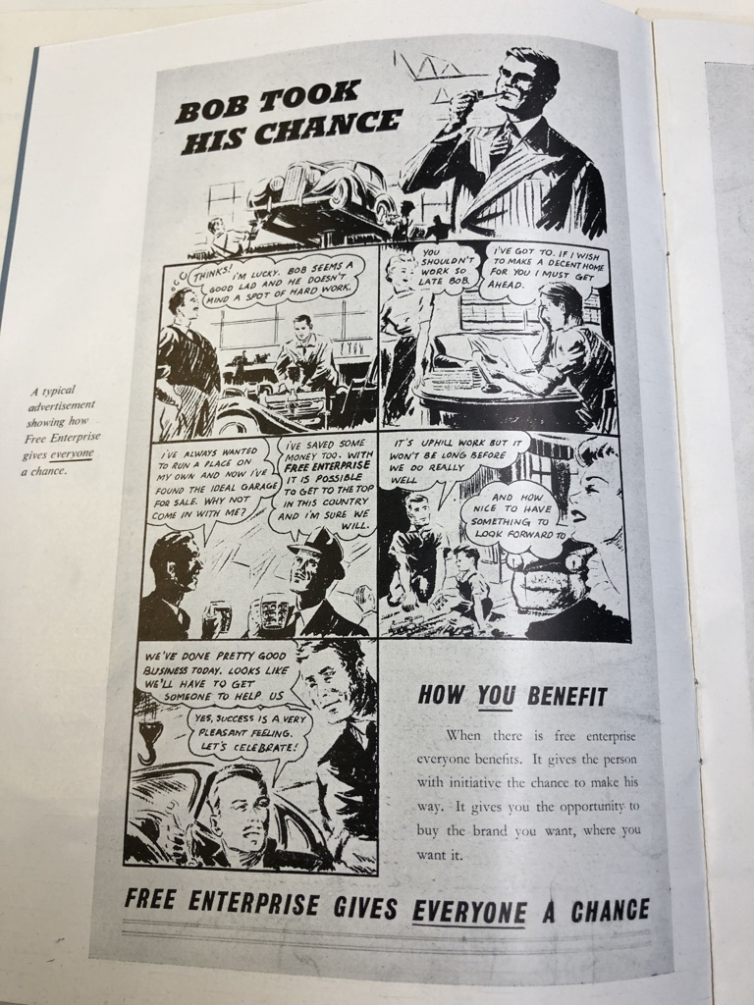

**Figure 2: ‘Britain was First with… Thanks to Free Enterprise’.[25]**

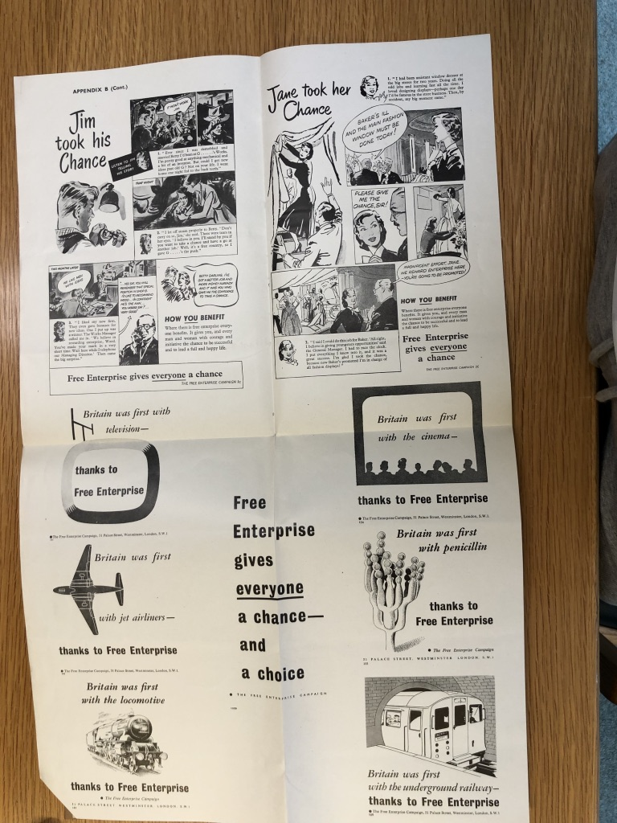

**The IoD as a Foundational Network: Strategy and Fundraising**

While the IoD might not have had much success with its efforts to alter public opinion through the free enterprise campaign, it did have a significant impact on the development of business and neoliberalism in the post-war years. Firstly, because it acted as a consciousness raising exercise, inspiring directors to organise against post-war social democracy. As a result, the institute birthed a network of organised business committed to the fight for free enterprise. As this movement grew and become more sophisticated, it developed new institutions such as the IEA, the IPG, which thanks to the IoD, meant there was already a corps of business figures, willing to fund efforts to oppose post-war social democracy. Indeed, many of the IoD’s members appear as participants and financiers of both the IEA and IPG, for instance, Paul Chambers, the Director of ICI and founder of the IPG served as Spears successor when he retired. Similarly, Marcus Sieff, the Chairman of M&S (1972-1982), who had given money to the free enterprise campaign, later became a fundraiser for the IEA.[26]

Furthermore, the development of these institutions had their roots in the IoD. In the early 1950s, the IoD served as a site for the advocacy of neoliberal arguments. The free enterprise campaign was an experiment in putting the argument for private enterprise before the public by neoliberals in the business community. It was in the context of this failure that the IEA and IPG developed their strategy, honing their argument and using more subtle and sophisticated methods to put their message to the British people. For instance, when formulating its strategy, the IEA aimed for academic integrity in order to avoid the pitfalls of the free enterprise campaign. This they argued, was ‘the difference between propaganda’ and effective ‘education’.[27] Overall, the IoD should be seen as pivotal in two regards. Firstly, for creating a network of business opposition to the post-war social democracy. Secondly, for creating a space for this network to pool their resources and experiment with different strategic approaches, laying the foundation for later developments and successes.

**Conclusion**

The role of the business community in the rise of neoliberalism in post-war Britain has often been understated in the historiography of the period, yet the evidence presented here demonstrates its importance. The IoD, under Edward Spears, played a key role in creating a network of business figures committed to opposing post-war social democracy and advancing neoliberal ideas. This network was essential for the rise of neoliberalism. The IoD laid the groundwork for later successes in promoting neoliberalism by creating a network of potential donors for the cause and mobilising this network to experiment with different methods of advocacy that shaped the development of successive institutions such as the IEA and IPG. Ultimately, the IoD functioned as a catalyst for a broader and more co-ordinated business led opposition to the Keynesian economic paradigm. This paper therefore highlights the importance of examining not just intellectuals and think tanks, but also the much more committed and organised efforts of the business community that enabled neoliberalism’s rise, offering a more comprehensive understanding of its development in Britain.

1. *The Neoliberal Age? Britain Since the 1970s*, edited by Aled Davis, Ben Jackson and Florence Sutcliffe-Braithwaite (London: UCL Press, 2021)
2. David Harvey, *A Brief Introduction to Neoliberalism* (Oxford: Oxford University Press, 2007) pp.67-8
3. Ewen Green, *Ideologies of Conservatism: Conservative Political Ideas in the Twentieth Century* (Oxford, Oxford University Press, 2002) pp.214-239.
4. Emily Robinson, Camilla Schofield, Florence Sutcliffe-Braithwaite, Natalie Thomlinson, ‘Telling Stories about Post-war Britain: Popular Individualism and the ‘Crisis’ of the 1970s’, *Twentieth Century British History*, 28 (2017) pp.268–304.
5. Richard Crockett, *Thinking the Unthinkable, Think Tanks and the Economic Counter Revolution 1931-1983* (London: Harper Collins, 1994)
6. Ben Jackson, ‘The Think-Tank Archipelago: Thatcherism and Neo-Liberalism’ In *Making Thatcher’s Britain*, edited by Ben Jackson and Robert Saunders (Cambridge: Cambridge University Press, 2012) pp.43–61 (p.47)
7. Neil Rollings, ‘Cracks in the Post-War Keynesian Settlement? The Role of Organised Business in Britain in the Rise of Neoliberalism Before Margaret Thatcher’, *Twentieth Century British History*, 24 (2013) pp.637–659.
8. Damien Cahill and Martin Konings, *Neoliberalism, Key Concepts Series* (Cambridge: Polity Press, 2017) pp.5-6
9. Phillip Mirowski and Dieter Plehwe ‘Introduction’ in, The Road from Mont Pelerin: The Making of the Neoliberal Thought Collective, edited by Phillip Mirowski and Dieter Plehwe (Massachusetts: Harvard University Press, 2009) pp.1-44 (pp.4-5)
10. Rollings (2013) p.642
11. Jamie Peck, *Constructions of Neoliberal Reason* (Oxford: Oxford University Press, 2010) p.42
12. Letter from Norman Kipping to Spears, 26th July 1951, Edward Spears Papers 3/2/14 (Churchill Archives: Cambridge); Rollings (2013)
13. Leonard David Gammans, ‘Does Industry Lack Courage?’ *Financial Times*, 15th November 1950. p.4
14. Edward Spears, The Success of the IoD, 1953 Edward Spears Papers 7/20. (Churchill Archives: Cambridge)
15. Edward Spears, The Institute of Directors, the Stock Exchange Gazette, 5th January 1951, Edward Spears Papers SPRS 3/2/19 (Cambridge: Churchill Archives)
16. Ibid
17. Report of the Membership Committee for 1951, 31st December 1951, Edward Spears Papers SPRS 3/2/14 (Churchill Archives: Cambridge)
18. IOD, ‘Minutes of the Policy Committee’, 8th December 1950, Edward Spears Papers SPRS 3/2/11 (Churchill Archives: Cambridge) p.2
19. Data Compiled from Incomplete Receipts of Donations to the Free Enterprise Campaign, Edward Spears Papers 3/2/17, 19, 30, 34 (Churchill Archives: Cambridge)
20. IOD, ‘Bob Took His Chance’ 1953, Advertisement Poster, Edward Spears Papers 3/2/17 (Churchill Archives: Cambridge)
21. IOD, ‘Declaration by the IOD’ c.1951, Edward Spears Papers 3/2/30 (Churchill Archives: Cambridge) p.2
22. IOD, ‘Free Enterprise Campaign Prospectus’ 1951, Edward Spears Papers 3/2/17 (Churchill Archives: Cambridge); Free Enterprise Campaign, November 1952 Edward Spears Papers SPRS 3/2/26 (Churchill Archives: Cambridge) p.2
23. IOD, ‘Minutes of Policy Committee’ 17th December 1951, Edward Spears Papers 3/2/19 (Churchill Archives: Cambridge)
24. IOD, ‘Bob Took His Chance’ 1953, Advertisement Poster, Edward Spears Papers 3/2/17 (Churchill Archives: Cambridge)
25. IOD, ‘Britain was First with… Thanks to Free Enterprise’ Advertisement Poster, 1953, Edward Spears Papers 3/2/17 (Churchill Archives: Cambridge)
26. IEA, Minutes of the 16th Meeting of Trustees, 28th July 1976, IEA papers (California: Hoover Institute)
27. IEA, Progress Report, 1974, Box 270, Folder 4, IEA Papers (Hoover Institute, California) p.4